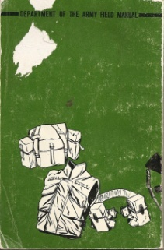Feild manual side.jpgFeild manual side.jpgFeild manual side.jpgFeild manual side.jpgFeild manual side.jpgFeild manual side.jpg